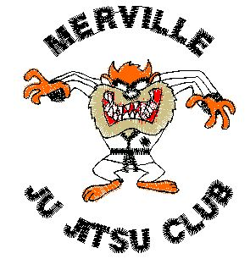
Merville Ju-Jitsu Club

Child Protection / Vulnerable Adults Policy

Merville Ju-Jitsu Club is fully committed to safeguarding the well being of its members. All members should show respect and understanding for the rights, safety and welfare of others, and conduct themselves in a way that reflects the principles of the Club. We believe that taking part in Martial Arts practice should be a positive and enjoyable part of children’s lives and to achieve this have the following aims:

- MJJC have adopted Kaizen Ju-Jitsu’s Duty of Care – Child Protection and Vulnerable Adults policies and procedures and are working within the parameters set by them.
- Club coaches and helpers should follow the Kaizen Ju-Jitsu Association Code of Ethics
- All Club coaches, helpers and officials working with young people should read and adhere to the Kaizen Child Protection and Harassment Policy. The Club will follow the guidance of the policy in the event of any concerns or allegations.
- The Club will ensure that anyone working with young people undertake a screening procedure.
- All Club members are made aware of the Club Code of Conduct
- The Club will obtain written Medical details of all Junior members which will be made known to coaches, where deemed appropriate and/or necessary.
- All Club coaches should be a fully paid up, current member of the club. The club will encourage and support helpers to gain qualifications and assist coaches to stay up-dated.
- The Club has in place a designated Child Protection, Vulnerable Adults and Harassment officer who should be contacted by anyone with concerns with respect to Child Abuse, Abuse or Harassment. If this officer is unavailable, they should contact the Club Chairman or the Kaizen Ju-Jitsu Child Protection /Harassment Officer.

Full guidelines for dealing with issues of this nature are available at www.mervillejujitsu.com

