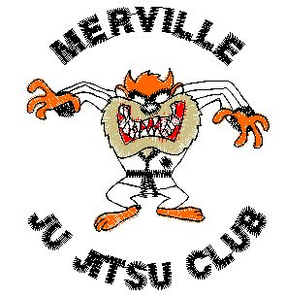
Welcome to
Merville Ju-Jitsu Club

Dear Parent/Guardian,

On behalf of Merville Ju-Jitsu Club , I would like to welcome your child to the club and provide you with some information about our activities.

The club provides opportunities for young people from age 7+ to receive coaching, exercise , skills development and access to a wide range of martial arts activities.

All classes are delivered by qualified coaches who are trained and have been screened for their suitability for working with young people. MJJ is committed to providing the highest safety standards , top quality coaching and a professional ‘club experience’. .

Our Club’s Designated Officers are Damian Brennan (Male) and Kate Cullinan (Female). They are responsible for ensuring that our Child Safeguarding policy is consistently implemented and can be contacted on 07906 131871 and 07751 061500 respectively, should you have any concerns.

We welcome parents as observers at all our training sessions and value your support throughout the year, but especially at gradings and on competition trips . We are keen to involve parents in the club’s external events, so please feel free to speak to any of the coaches or committee members about the club, how competitions are organized and how you could be of help !

Classes run routinely every Thursday evening , starting at 6.45pm sharp. Juniors are encouraged to be arrive fully prepared for training, at least 10 minutes prior to the starting time.

Each child is encouraged to bring all their belongings and a drink in a kit bag , to ensure they have somewhere separate to store their possessions / personal kit.

Children must be brought into and collected directly from the main training hall. They are not permitted to wait outside the building unaccompanied, for their own safety.

The Club can provide basic training equipment such as gloves, shinguards, etc for the first few sessions , but experience suggests that most children and parents prefer to purchase their own personal items to ensure a better fit and higher hygiene levels.

The first lesson is free for all new members . After that you can choose to pay week by week or pay the fixed term fee which is significantly cheaper . Exact fees will be explained on the night.

We would be grateful if you could complete the attached junior club membership form. For the safety of your child it is important that the club is informed of any medical condition or allergies that may be relevant, should your child fall ill or be involved in an accident while at the club.

If you would like to talk to someone at the club about this information or your child’s involvement with the club, please contact :

Senior Club Coach : Robert Cullinan ( by e-mail) robert.cullinan@sky.com

We thank you for your co-operation and look forward to meeting you at some point in the future.

Yours sincerely,

SIGNED: DATE:

